How to Configure Sales Commissions in Odoo 19
Rohan Raj — Infintor Solutions | March 2026

Introduction
Sales commissions in Odoo 19 allow businesses to automate incentive calculations for their sales teams. Instead of tracking targets and payouts manually in spreadsheets, the Commissions module handles achievement tracking, tiered payouts, and payroll integration directly within the Sales app.
This guide covers how to enable commissions, create commission plans, configure targets and achievements, and generate commission reports in Odoo 19.

Enabling the Commissions Module
Go to Sales → Configuration → Settings. Under the Invoicing section, enable the Commissions checkbox and click Save.
Once enabled, a new Commissions menu appears under the Sales app with five sub-menus:
- My Commissions — view commission data for the logged-in user only
- Commissions — view calculated commission data for all salespeople
- Achievements — view achievement records across plans
- Commission Plans — create and manage commission plans
- Adjustments — make manual corrections to commission figures
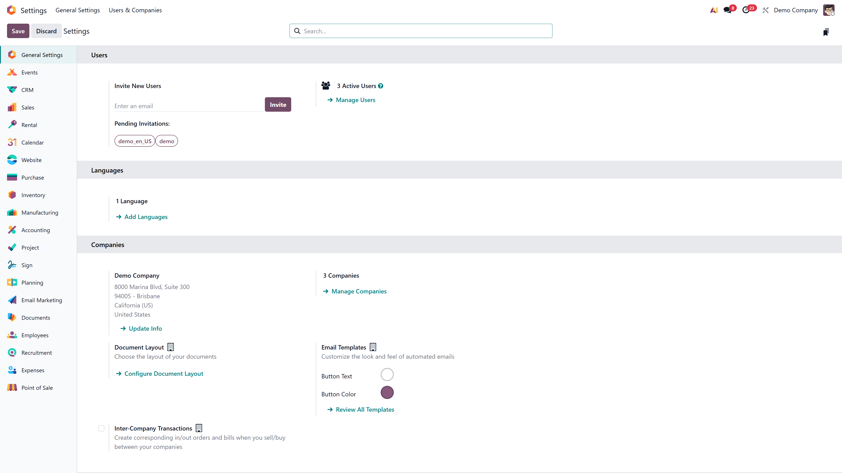
Sales Settings with Commissions enabled

Creating a Commission Plan
Sales → Commissions → Commission Plans → New
Fill in the following fields:
- Name — a descriptive label for the plan (e.g., “Q1 2026 Sales Incentive”)
- Type — select Targets (goal-based with tiers) or Achievements (flat rate on actuals)
- User Type — choose Salesperson (individual tracking) or Sales Team (collective tracking)
- On Target Commission — the payout amount at 100% target achievement (default: 1,000)
- Effective Period (From / To) — the plan’s start and end dates
- Periodicity — how often targets reset: Monthly, Quarterly, or Yearly
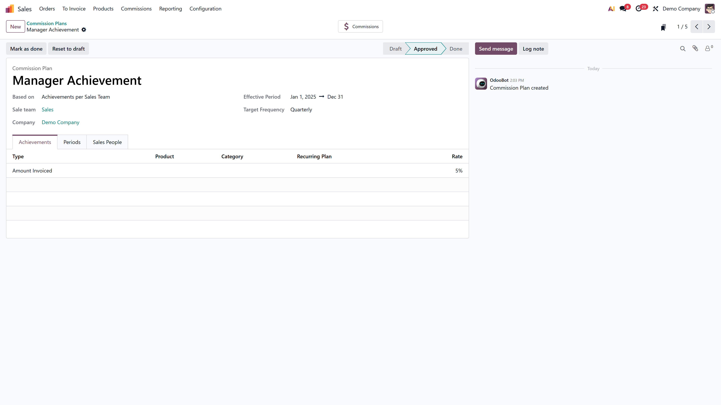
Commission Plan form with header fields

Target-Based vs Achievement-Based Plans

Feature | Target-Based | Achievement-Based
How it works | Set a sales goal per period; payout based on % achieved | Flat commission rate on actual performance
Commission Levels (tiers) | Yes — define payouts at 0%, 50%, 100%, 150% | No — single flat rate
Best for | Quarterly/yearly goals with escalating incentives | Ongoing, consistent commission structures
Target amounts required | Yes | No

Setting Up Targets
For target-based plans, Odoo auto-generates periods in the Periods tab based on the selected periodicity. Each period includes a target amount and a payment date that you can edit individually. The Targets tab shows the overall target amounts per period.

Setting Up Achievements
Go to the Achievements tab and configure:
- Type — Amount Invoiced, Amount Sold, Quantity Invoiced, or Quantity Sold
- Rate — multiplier applied to the achievement (default: 0.05 i.e. 5%)
- Product — optional specific product filter
- Category — optional product category filter to commission only specific product categories

Achievements tab with Type set to Amount Invoiced

Assigning Salespeople
In the Sales People tab, add the salespeople who will be tracked under this plan. Each entry allows:
- Custom From and To dates for mid-period additions or removals
- Individual tracking within individual plans or team-level tracking within team plans

Commission Levels
For target-based plans, the Commissions tab lets you define tiered payouts:
- 0% of target → ₹0
- 50% of target → ₹10,000
- 100% of target → ₹30,000
- 150% of target → ₹45,000
Odoo interpolates linearly between levels.
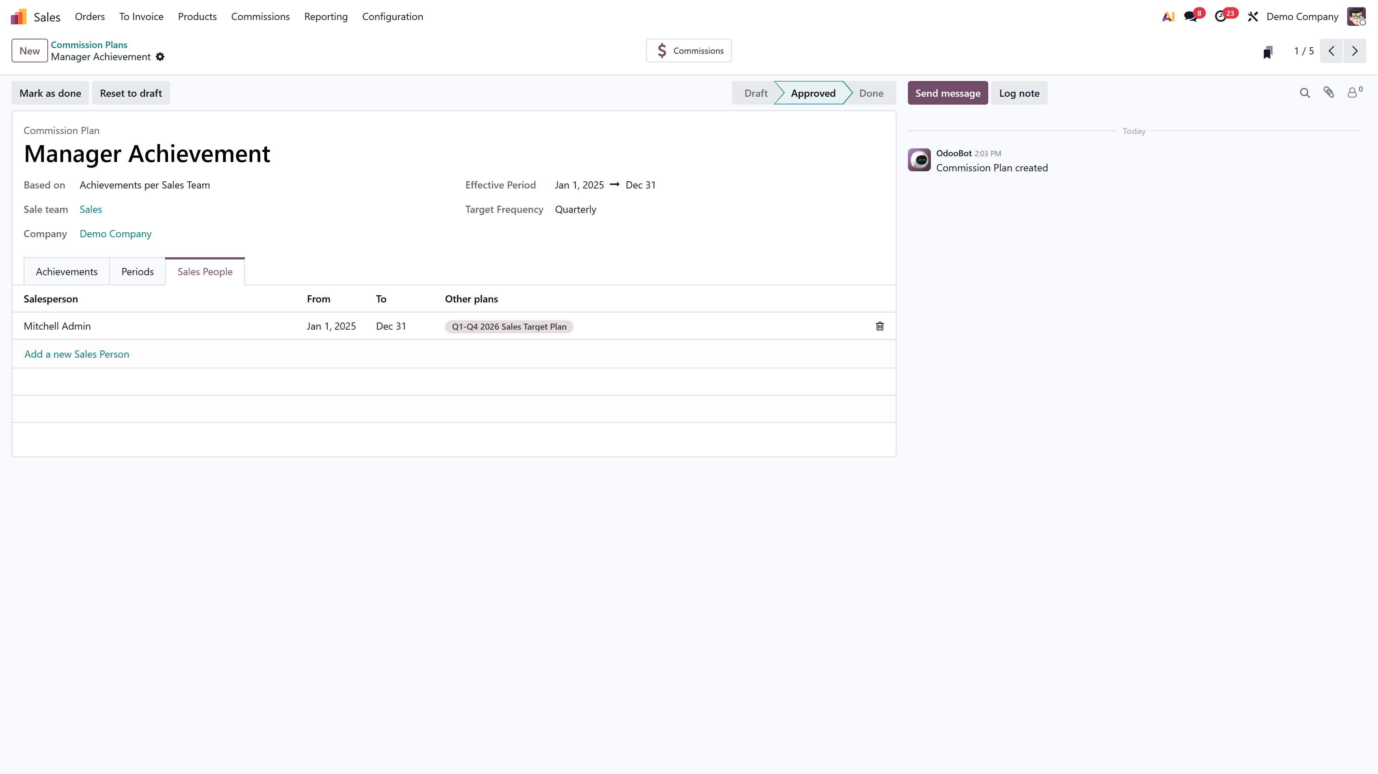
Commissions tab showing tiered payout structure

Adjustments
Go to Sales → Commissions → Adjustments to make manual corrections. Adjustments are managed as a separate list, not as a tab on the plan form. Each adjustment records:
- Achieved — the correction value
- Add to — salesperson whose commission increases
- Reduce From — salesperson whose commission decreases (optional)
- Date and Note for audit trail

Approving the Plan
Click Approve to activate the plan. Once approved, Odoo begins tracking sales and calculating commissions automatically. The plan moves through four states: Draft → Approved → Done (or Cancelled). To make changes to an approved plan, it must be Reset to Draft first.

Payroll Integration
With the HR Payroll module installed, each plan gets a Payslip Input field. Link it to a payroll input type (e.g., “Sales Commission”) so that calculated commissions appear automatically in employee payslips.

Viewing Commission Reports
Go to Sales → Reporting → Commissions to view commission data in pivot or graph format. Filter by salesperson, plan, or date range. Each salesperson can also view their own data through the My Commissions menu.
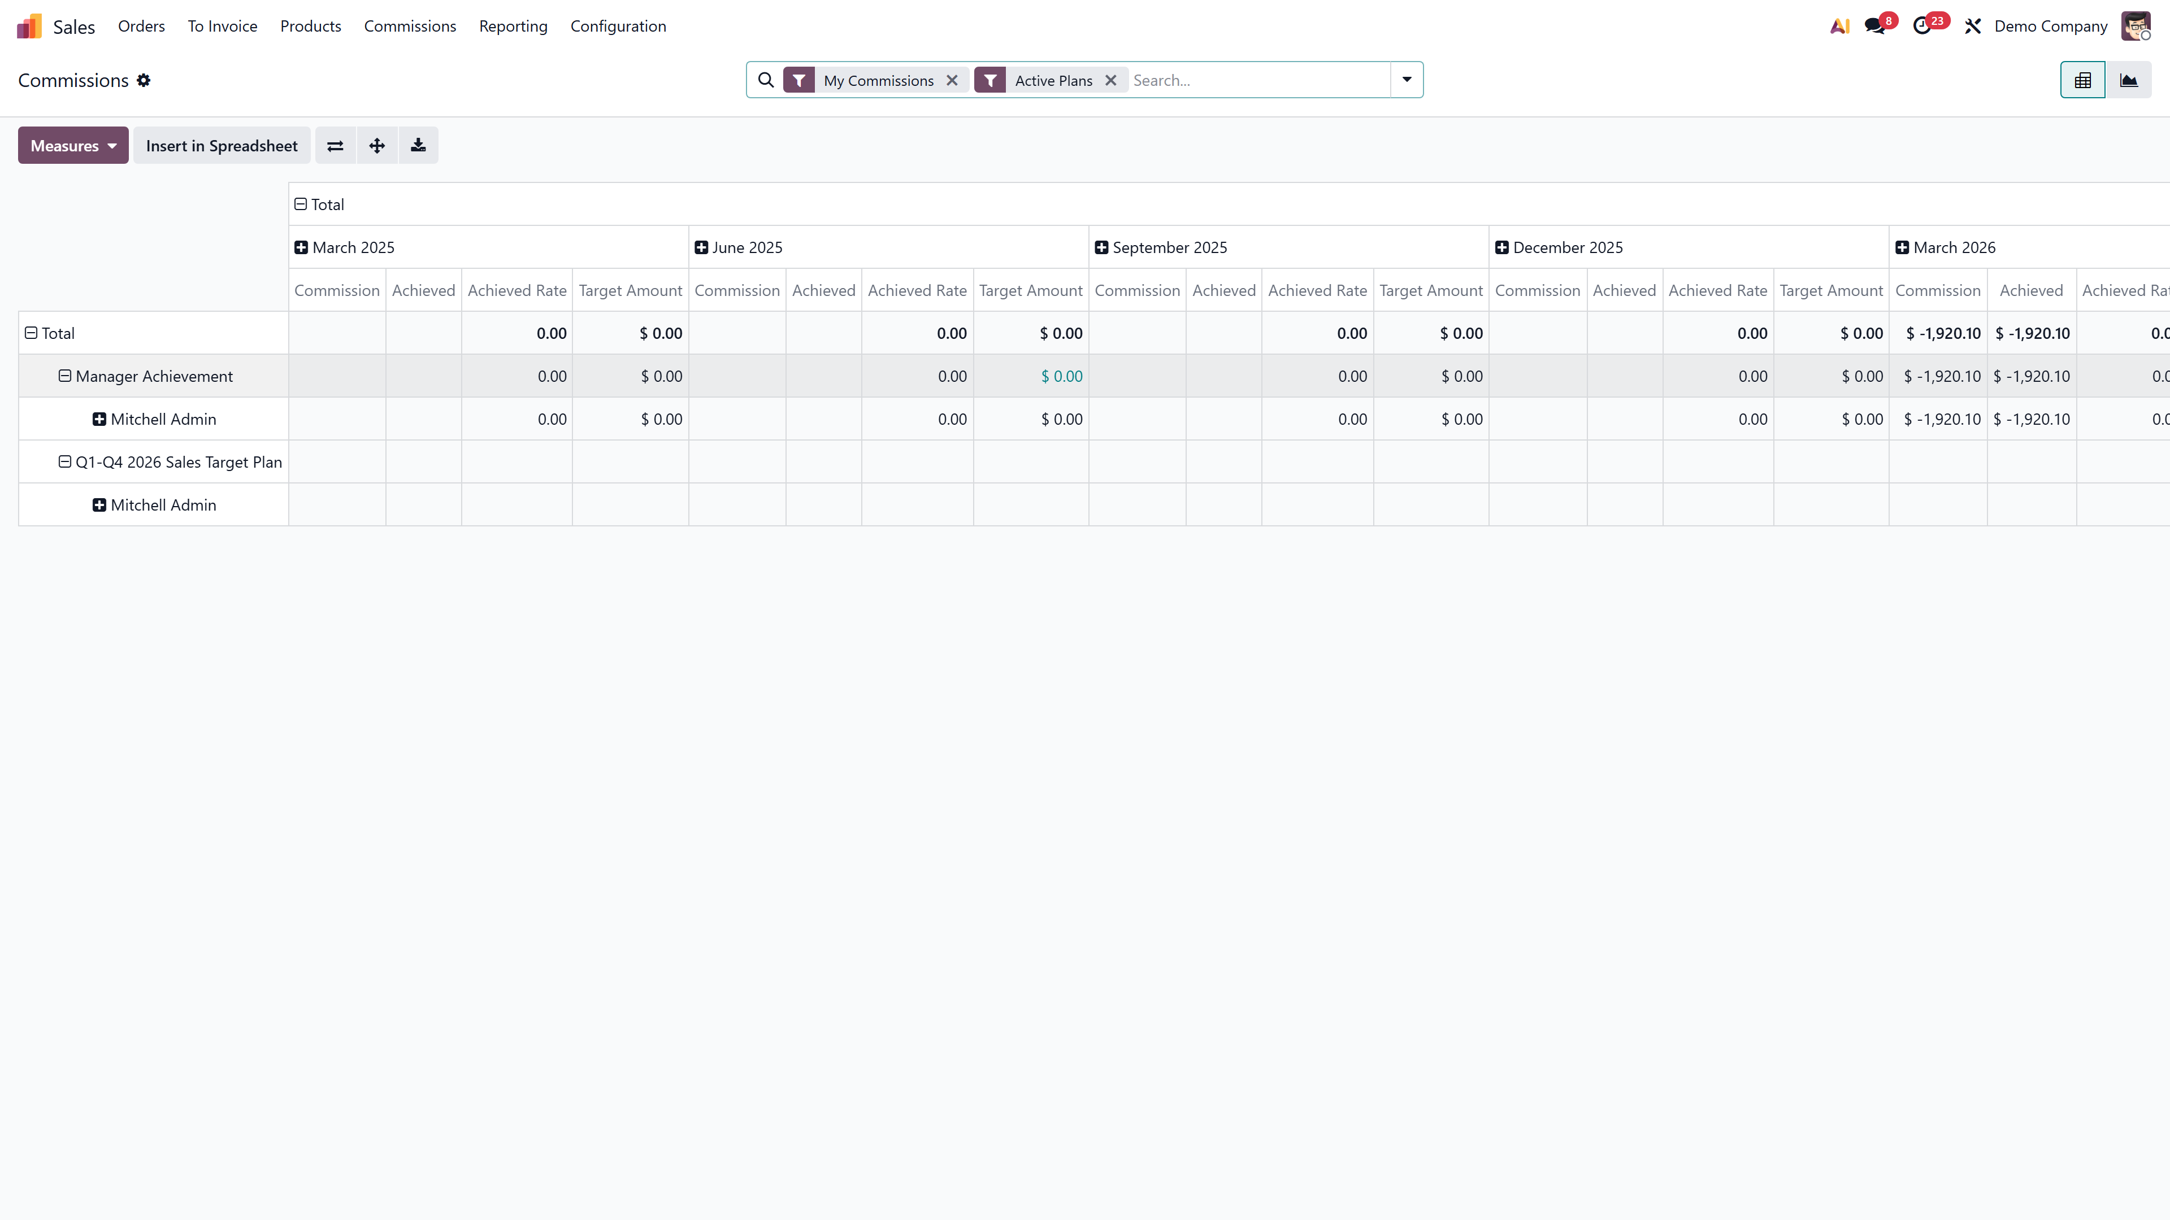
Commission reporting pivot view with per-salesperson breakdown

FAQs
1. Can a salesperson have multiple active commission plans?
Yes. Plans track independently. A salesperson can be part of both a target-based and an achievement-based plan at the same time.
2. What happens when a salesperson joins mid-quarter?
Use the custom From date in the Sales People tab. The salesperson will only be evaluated from that date onward.
3. Can I commission on specific product categories only?
Yes. Set the Category field on the achievement line to filter by product category.

Automate your sales commission process with Odoo 19. Connect with us at infintor.com for expert guidance.

